

**Computer Science OR Information Technology**

Instructor: Dr. G.E. Antoniou

Day, Month, Year

Day

Number-title-of the course

Assessment Module-??

Last, First (name)

Department of CSIT

# Problem 1: QUADRATIC EQUATION ($s0)

**Arithmetic example (Assembly Language).**

**Solution:**

Formula that calculates the delta for the following quadratic equation:

$$∆ =b^{2}-4ac$$

The program reads the values of a, b, and c from the user and loads them in the register. The program calculates the value of $b^{2}$ first. Then, it calculates the value of $4ac$. To do this we load the value 4 in a register. We subtract $4ac$ from $b^{2}$. Then, the program outputs the value to the user.

**Code:**

# Homework X . Problem 1

# This program calculates the value: Delta = b^2 - 4ac

.text

.globl main

main:

# prints "This program calculates the Delta for quadratic equations: "

la $a0, welcomeMessage

li $v0, 4

syscall

# prints "Please enter a: "

la $a0, entera

li $v0, 4

syscall

# inputs the value a

li $v0, 5

syscall

move $t0, $v0

# prints "Please enter b: "

la $a0, enterb

li $v0, 4

syscall

# inputs the value b

li $v0, 5

syscall

move $t1, $v0

# prints "Please enter c: "

la $a0, enterc

li $v0, 4

syscall

# inputs the value c

li $v0, 5

syscall

move $t2, $v0

# calculates b^2 and puts it in #s0

mult $t1, $t1

mflo $s0

# loads the constant 4 at $t4

li $t4, 4

# calculates 4*a and puts it in $s1

mult $t4, $t0

mflo $s1

# calculates 4*a*b and puts it in $s1

mult $s1, $t2

mflo $s1

# calculates delta = b^2-4*a*c and puts it in $s0

sub $s0, $s0, $s1

# prints "Delta is: "

la $a0, answer

li $v0, 4

syscall

# prints the output of the operation ($s0)

move $a0, $s0

li $v0, 1

syscall

# exits the program

li $v0, 10

syscall

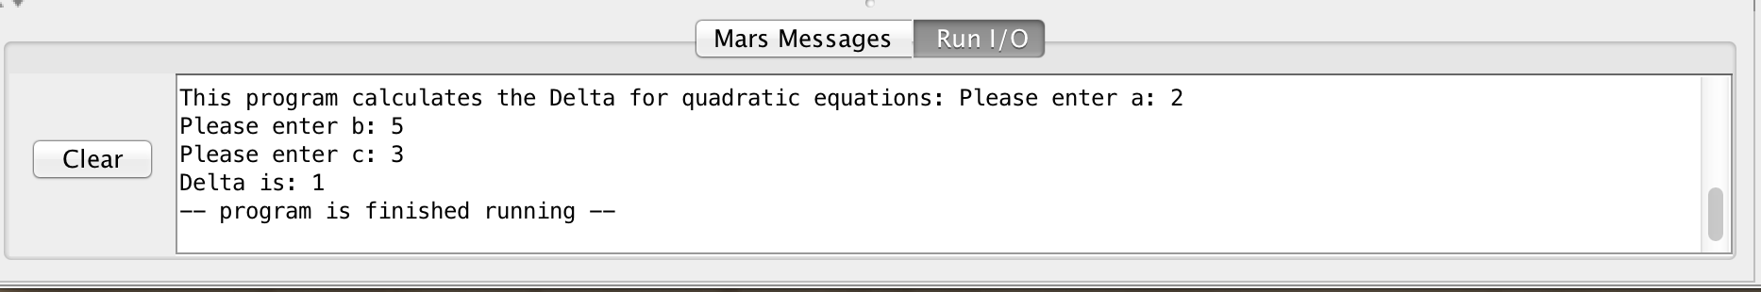**Sample Run (Console):**

.data

welcomeMessage:

.asciiz "This program calculates the Delta for quadratic equations: "

entera:

.asciiz "Please enter a: "

enterb:

.asciiz "Please enter b: "

enterc:

.asciiz "Please enter c: "

answer:

.asciiz "Delta is: "

**Sample Run (Registers area), only in decimal:**

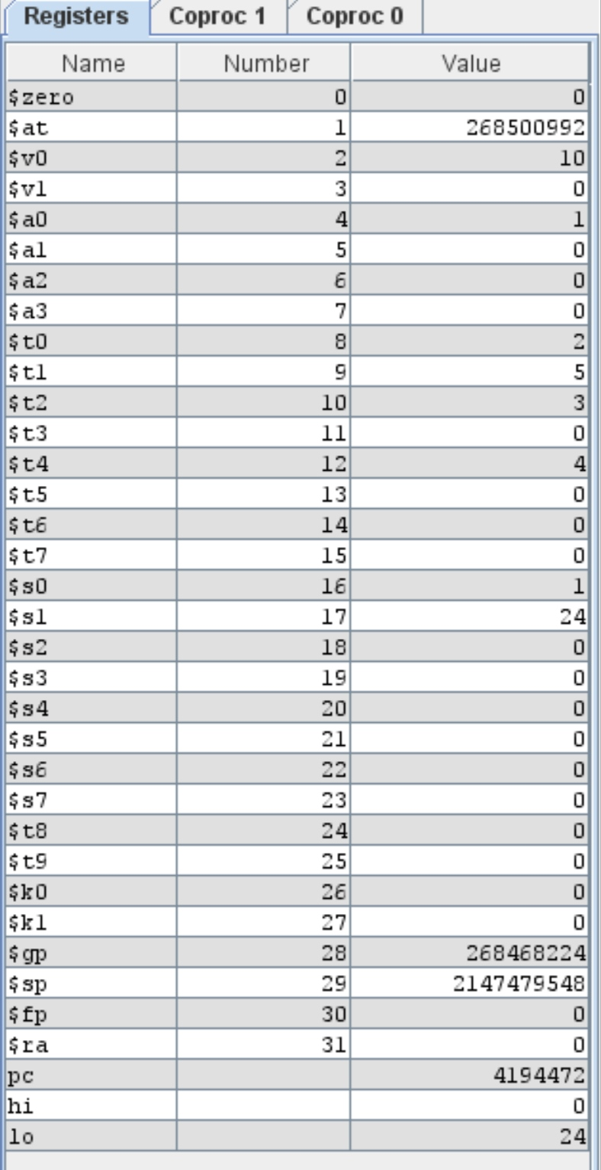

**Result:**

State the final answer (result): **Δ = 1.**

# Brief Comments:

The program runs correctly, according to the specifications.